**Name:** V Venkata Sri Prasad

**Batch:** Data Engineering

**Date:** 22/01/2024 – (Day 4)

**Topics:**

1. **Joins and joins using groupby, havingby**
2. **Subqueries**
3. **Union, Intersect and Except**

**EQUI Joins**

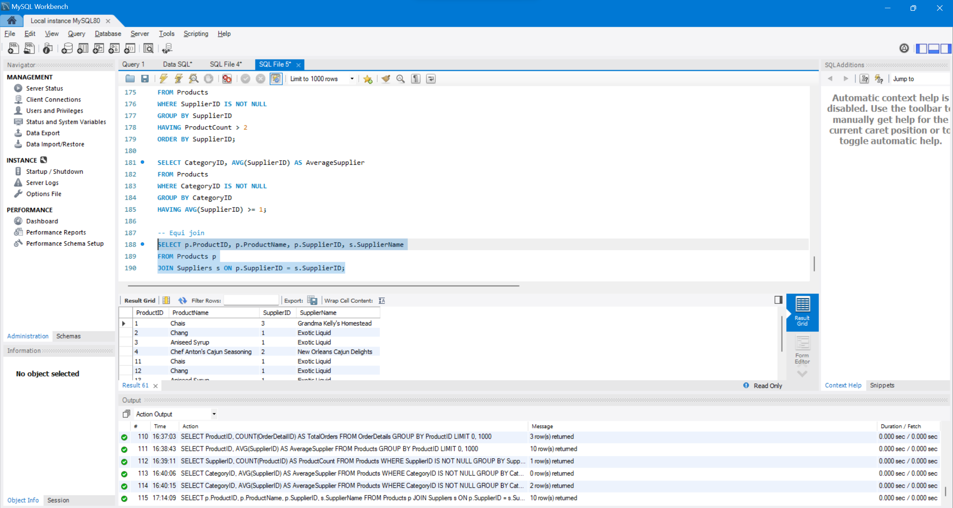

**Using a Self Join**

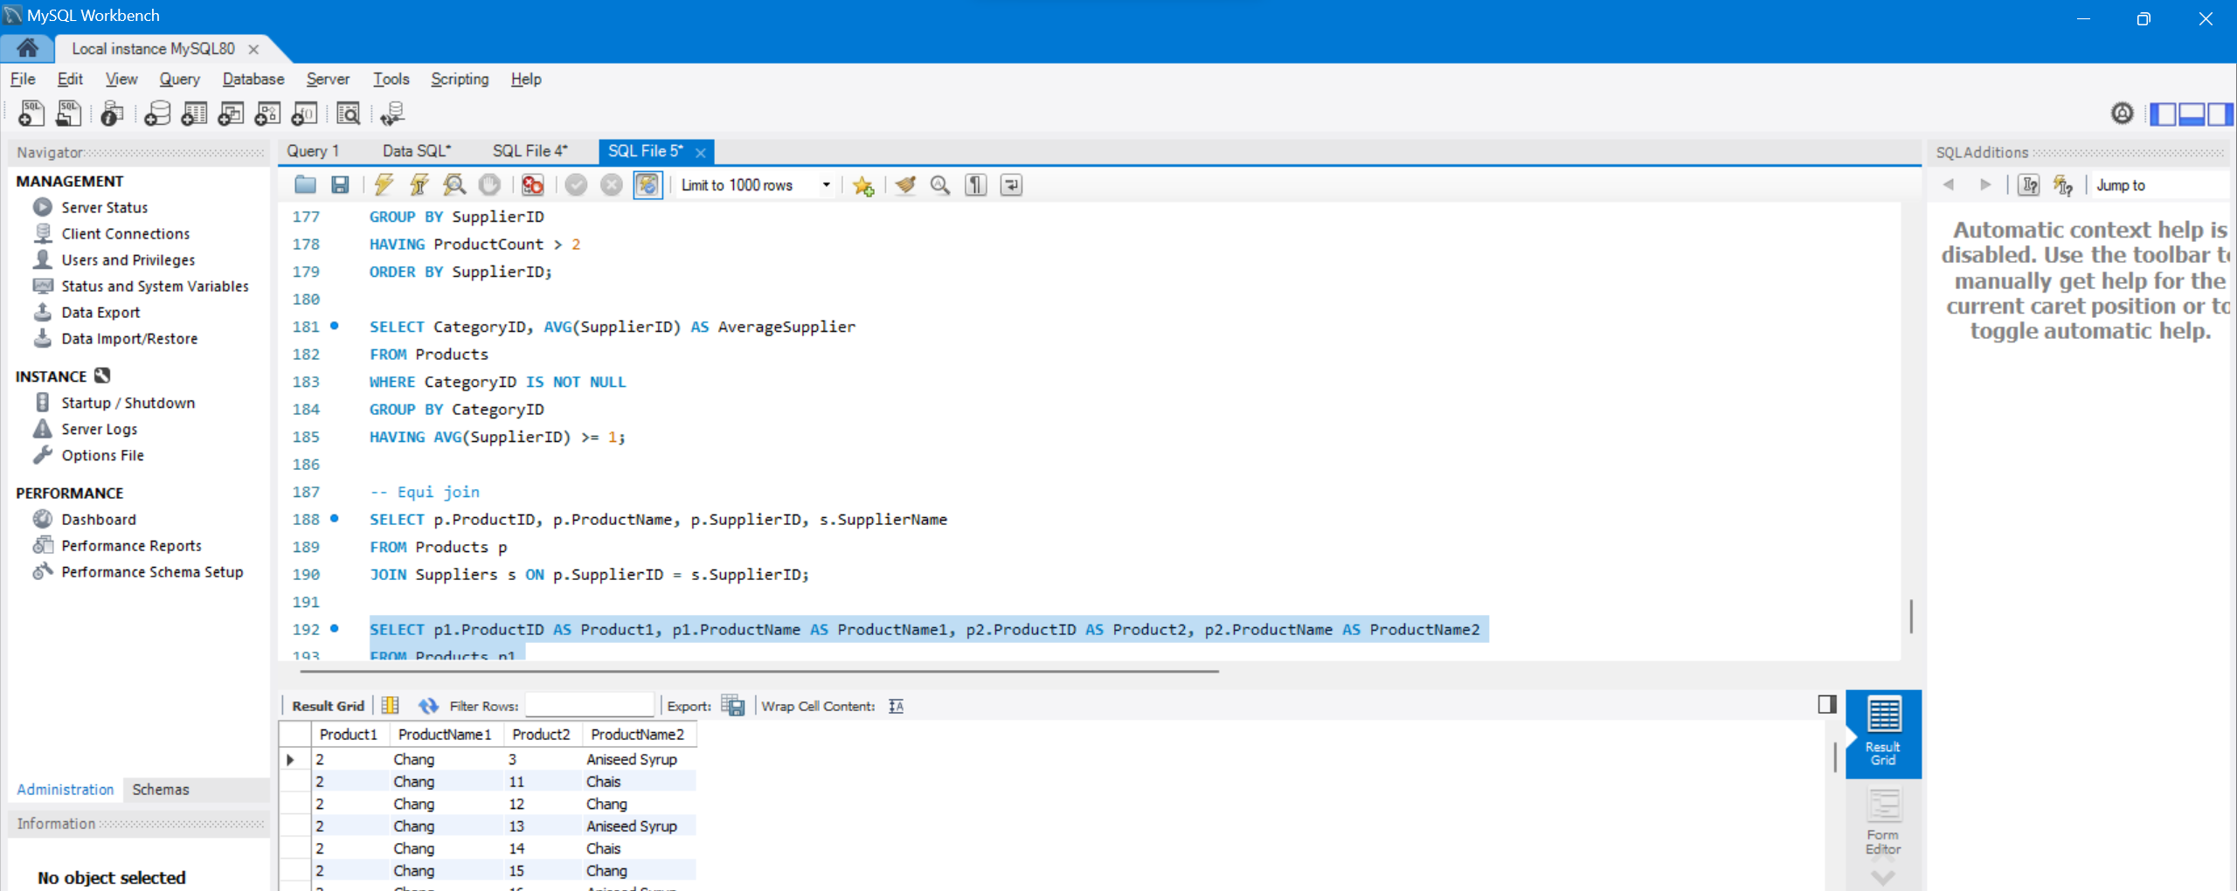

**Joins with groupby, having by, grouping sets**

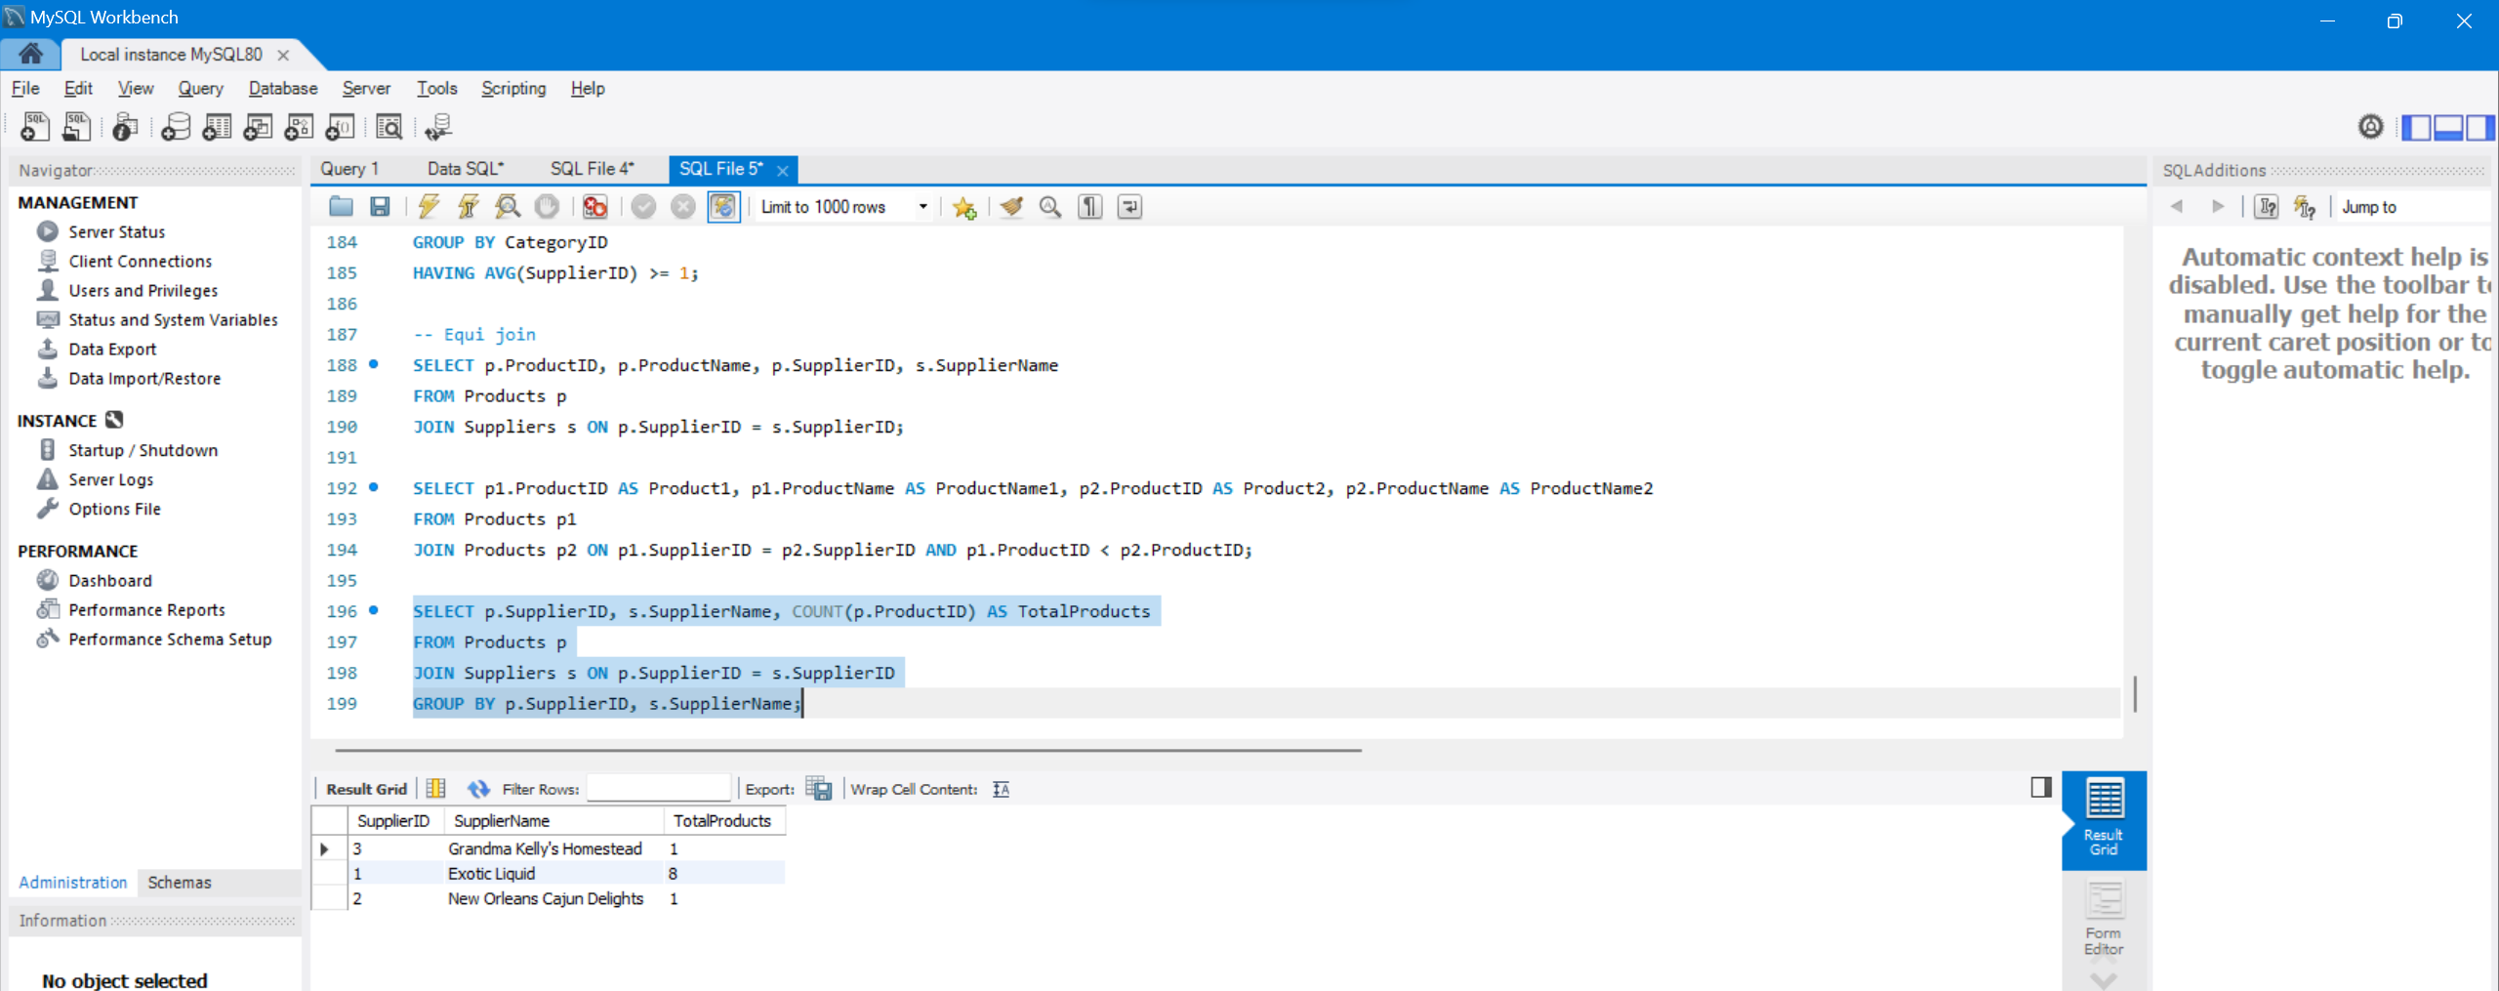

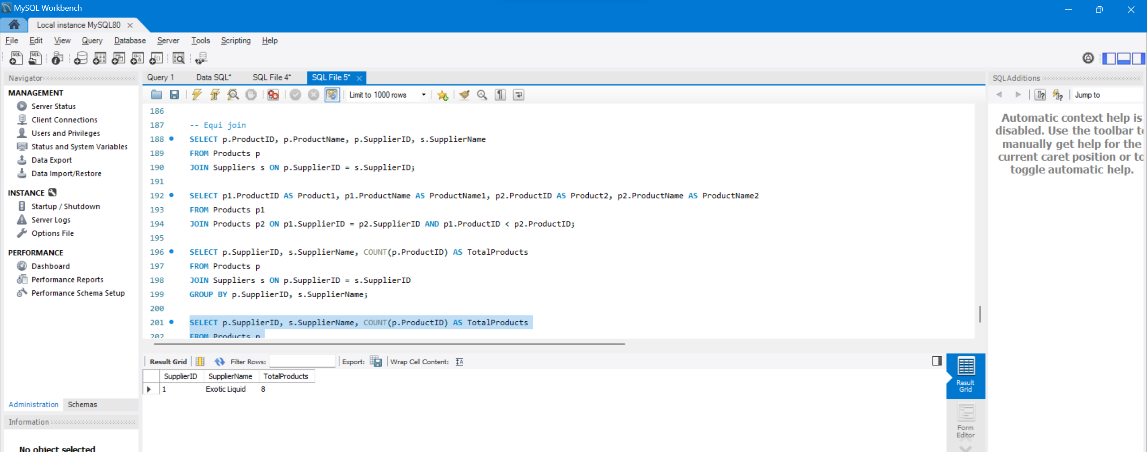

**Using Nested Subqueries**

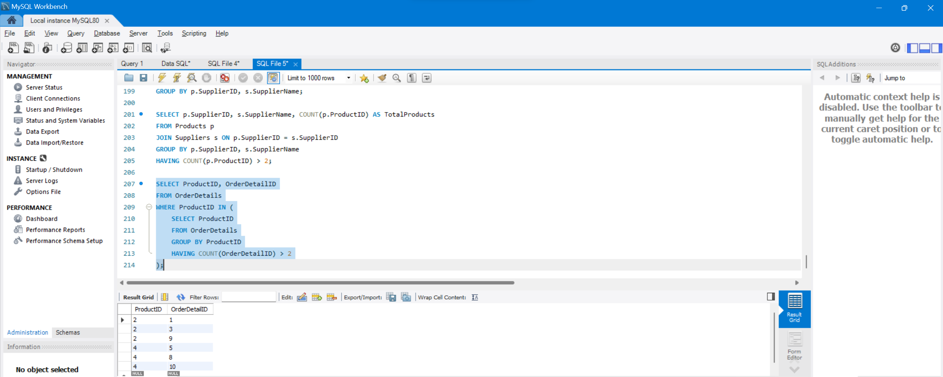

**Using Correlated Subqueries**

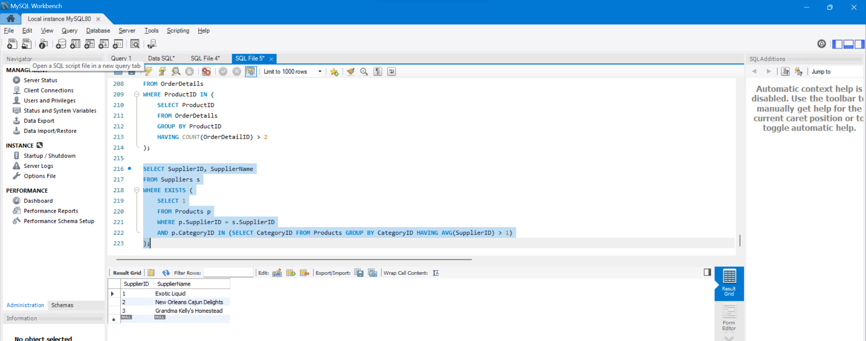

**Using UNION,INTERSECT,EXCEPT**

**UNION:**

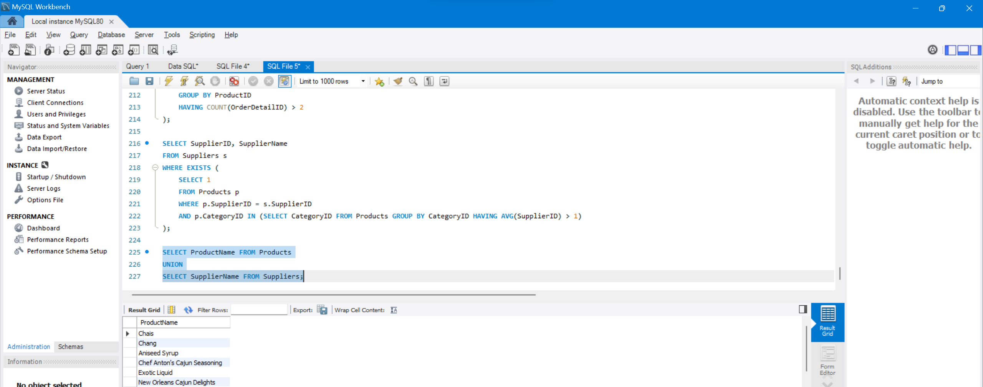

**INTERSECT:**

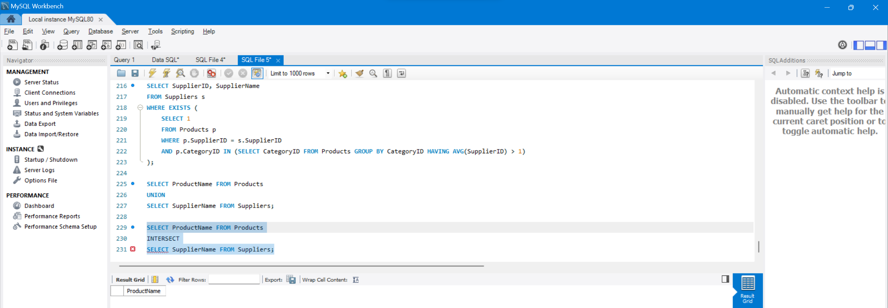

**EXCEPT**

